Project Design Phase-II
Data Flow Diagram & User Stories

Date | 26 February 2026
Team ID | LTVIP2026TMIDS40509
Project Name | Exploratory-Analysis-Of-RainFall-Data-In-India-For-Agriculture
Maximum Marks | 4 Marks

Data Flow Diagrams:
A Data Flow Diagram (DFD) is a traditional visual representation of the information flows within a system. A neat and clear DFD can depict the right amount of the system requirement graphically. It shows how data enters and leaves the system, what changes the information, and where data is stored.

Example:
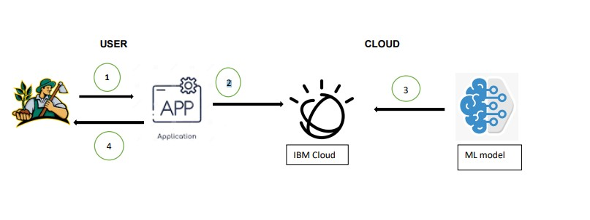

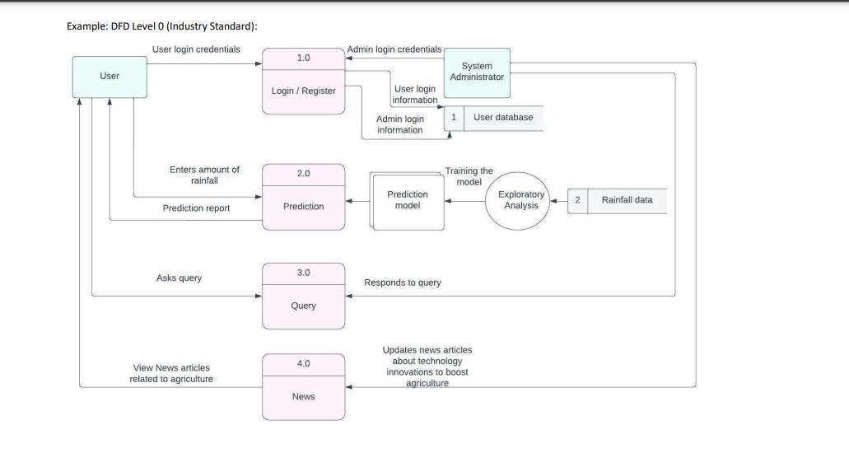

User Stories
Use the below template to list all the user stories for the product.
User Type | Functional  Requirement  (Epic) | User Story  Number | User Story / Task | Acceptance criteria | Priority | Release
Customer  (Mobile user) | Registration | USN-1 | As a user, I can register for the application by entering my email, password, and confirming my password. | I can access my account / dashboard | High | Sprint-1
 | Registration | USN-2 | As a user, I will receive confirmation email once I have registered for the application | I can receive confirmation email & click confirm | High | Sprint-2
 | Login | USN-3 | As a user, I can log into the application by entering email &password | I can access the system | High | Sprint-1
 | Dashboard | USN-4 | As a user, I can view the details about the system and can navigate through the pages. | I can navigate through pages | High | Sprint-3
 | Prediction | USN-5 | As a user, I can enter the rainfall amount and get the prediction results | I can get the prediction result | High | Sprint-4
 | News | USN-6 | As a user, I can view latest news articals related to agriculture | I can view the articals | Medium | Sprint-3
Customer care executive | Contact | USN-7 | As a user, I can ask queries regarding the system | I can clarify my doubts | High | Sprint-3
 | Chat bot | USN-8 | As a user, I can interact with cahtbot to ask queries | I can get my queries clear instantly. | Low | Sprint-4
Administrator | login | USN-9 | As a user, I can register for the application by entering my email, password, and confirming my password. | I can view and update the system. | High | Sprint-1

